*********** 主界面布局代码**************
<?xml version="1.0" encoding="utf-8"?>
<LinearLayout xmlns:android="http://schemas.android.com/apk/res/android"
xmlns:app="http://schemas.android.com/apk/res-auto"
xmlns:tools="http://schemas.android.com/tools"
android:layout_width="match_parent"
android:layout_height="match_parent"
tools:context=".MainActivity"
android:background="#ffa"
android:orientation="vertical">
<TextView
android:layout_width="match_parent"
android:layout_height="wrap_content"
android:text="动物百科"
android:gravity="center_horizontal"/>
<androidx.recyclerview.widget.RecyclerView
android:id="@+id/rv_animal"
android:layout_width="match_parent"
android:layout_height="match_parent"/>
</LinearLayout >

*********** 单列视图代码实现**************
package com.example.myapplication0304;

import androidx.annotation.NonNull;
import androidx.appcompat.app.AppCompatActivity;
import androidx.recyclerview.widget.LinearLayoutManager;
import androidx.recyclerview.widget.RecyclerView;
import androidx.recyclerview.widget.StaggeredGridLayoutManager;

import android.annotation.SuppressLint;
import android.content.Intent;
import android.graphics.Rect;
import android.os.Bundle;
import android.os.Handler;
import android.provider.ContactsContract;
import android.view.View;
import android.view.ViewGroup;
import android.widget.ImageView;
import android.widget.TextView;
import android.widget.Toast;

public class MainActivity extends AppCompatActivity {

private RecyclerView rv_animal;

private int[] images={R.drawable.cat,R.drawable.dog,R.drawable.bird,R.drawable.cat,R.drawable.dog,R.drawable.bird};
private String[] names={"猫","狗","鸟","猫","狗","鸟"};
private int[] infos={R.string.cat,R.string.dog,R.string.bird,R.string.cat,R.string.dog,R.string.bird};
@Override
protected void onCreate(Bundle savedInstanceState) {
super.onCreate(savedInstanceState);
setContentView(R.layout.activity_main);

rv_animal = findViewById(R.id.rv);
//设置布局管理器
rv_animal.setLayoutManager(new LinearLayoutManager(getApplicationContext(),LinearLayoutManager.VERTICAL,false));
//设置适配器
rv_animal.setAdapter(new MyAdapter());
//设置itemView间的间隔
rv_animal.addItemDecoration(new MyDecoration());

}

private class MyAdapter extends RecyclerView.Adapter<MyAdapter.MyHolder> {
@NonNull
@Override
//将itemlayout布局转成转成视图，给MyHolder。
public MyHolder onCreateViewHolder(@NonNull ViewGroup parent, int viewType) {
View view = View.inflate(getApplicationContext(),R.layout.itemlayout,null);//将itemlayout布局转成转成视图
MyHolder myHolder = new MyHolder(view);//将得到的视图给MyHolder。
return myHolder;
}

@Override
//制定每个holder里的每个控件的具体内容；
public void onBindViewHolder(@NonNull MyHolder holder, int position) {
holder.miv_image.setBackgroundResource(images[position]);
holder.mtv_name.setText(names[position]);
holder.mtv_info.setText(infos[position]);
//给每个itemView设置点击事件，跳转到相应的界面。
holder.itemView.setOnClickListener(new View.OnClickListener() {
@Override
public void onClick(View view) {
Intent mintent = null;
switch (position){
case 0:{
mintent = new Intent(MainActivity.this,CatActivity.class);
break;
}
case 1:{
mintent = new Intent(MainActivity.this,DogActivity.class);
break;
}
}
startActivity(mintent);
}
});

}

@Override
//给出item的数量
public int getItemCount() {
return names.length;
}
//声明MyHolder里面都有哪些控件，并和itemlayout里面的控件一一对应
public class MyHolder extends RecyclerView.ViewHolder {
ImageView miv_image;
TextView mtv_name,mtv_info;
public MyHolder(@NonNull View itemView) {
super(itemView);
miv_image = itemView.findViewById(R.id.iv_image);
mtv_name = itemView.findViewById(R.id.tv_name);
mtv_info = itemView.findViewById(R.id.tv_information);
}
}
}
//自定义itemView的间隔
class MyDecoration extends RecyclerView.ItemDecoration{
@Override
public void getItemOffsets(@NonNull Rect outRect, @NonNull View view, @NonNull RecyclerView parent, @NonNull RecyclerView.State state) {
super.getItemOffsets(outRect, view, parent, state);
// outRect.set(0,0,0,20);
outRect.set(0,0,0,getResources().getDimensionPixelOffset(R.dimen.dividerHeight));
}
}
}

**********************文字资源存储*******************
<resources>
<string name="app_name">My Application0304</string>
<string name="cat">属于猫科动物，分家猫、野猫，是全世界家庭中较为广泛的宠物。家猫的祖先据推测是古埃及的沙漠猫，波斯的波斯猫，已经被人类驯化了3500年（但未像狗一样完全地被驯化）。</string>
<string name="dog">属于脊索动物门、脊椎动物亚门、哺乳纲、真兽亚纲、食肉目、裂脚亚目、犬科动物。中文亦称“犬”，狗分布于世界各地。狗与马、牛、羊、猪、鸡并称“六畜”。有科学家认为狗是由早期人类从灰狼驯化而来，驯养时间在4万年前~1.5万年前。被称为“人类最忠实的朋友”，是饲养率最高的宠物，其寿命大约在12~18年。</string>
<string name="bird">又称作鸟儿。定义：体表被覆羽毛的卵生脊椎动物，鸟的主要特征是：身体呈流线型（纺锤型或梭形），大多数飞翔生活。体表被覆羽毛，一般前肢变成翼（有的种类翼退化）；胸肌发达；直肠短，食量大消化快，即消化系统发达，有助于减轻体重，利于飞行；心脏有两心房和两心室，心搏次数快。体温恒定。呼吸器官除具肺外，还具有多个气囊辅助呼吸，使得鸟类无论在吸气和呼气时，均有氧气通过肺，即双重呼吸。</string>
<string name="alert">温馨提示：近期有不法分子攻击我司网站，盗取用户信息，进行电信诈骗，请大家注意保护账号安全，避免上当。</string>
</resources>
以下为itemlayout中的模板定义：
<?xml version="1.0" encoding="utf-8"?>
<LinearLayout xmlns:android="http://schemas.android.com/apk/res/android"
android:layout_width="match_parent"
android:layout_height="wrap_content"
android:orientation="horizontal">

<ImageView
android:id="@+id/iv_image"
android:layout_width="200dp"
android:layout_height="200dp"
android:scaleType="fitXY"/>
<LinearLayout
android:layout_width="match_parent"
android:layout_height="match_parent"
android:orientation="vertical">
<TextView
android:id="@+id/tv_name"
android:layout_width="match_parent"
android:layout_height="wrap_content"
android:text="动物名"
android:textSize="25sp"
android:textColor="#8E0858"
android:padding="10dp"
android:background="@color/white"/>
<TextView
android:id="@+id/tv_information"
android:layout_width="match_parent"
android:layout_height="match_parent"
android:text="动物介绍"
android:paddingLeft="10dp"
android:ellipsize="end"
android:background="@color/white"/>
</LinearLayout>
</LinearLayout>

**********************stagger瀑布流的视图实现代码*******************
package com.example.myapplication0304;

import androidx.annotation.NonNull;
import androidx.appcompat.app.AppCompatActivity;
import androidx.recyclerview.widget.LinearLayoutManager;
import androidx.recyclerview.widget.RecyclerView;
import androidx.recyclerview.widget.StaggeredGridLayoutManager;

import android.annotation.SuppressLint;
import android.content.Intent;
import android.graphics.Rect;
import android.os.Bundle;
import android.os.Handler;
import android.provider.ContactsContract;
import android.view.View;
import android.view.ViewGroup;
import android.widget.ImageView;
import android.widget.TextView;
import android.widget.Toast;

public class MainActivity extends AppCompatActivity {

private RecyclerView rv_animal;

private int[] images={R.drawable.cat,R.drawable.dog,R.drawable.bird,R.drawable.cat,R.drawable.dog,R.drawable.bird};
private String[] names={"猫","狗","鸟","猫","狗","鸟"};
private int[] infos={R.string.cat,R.string.dog,R.string.bird,R.string.cat,R.string.dog,R.string.bird};
@Override
protected void onCreate(Bundle savedInstanceState) {
super.onCreate(savedInstanceState);
setContentView(R.layout.activity_main);

rv_animal = findViewById(R.id.rv);
//设置布局管理器

// 设置线性布局
// rv_animal.setLayoutManager(new LinearLayoutManager(getApplicationContext(),LinearLayoutManager.VERTICAL,false));
// 设置瀑布流布局
rv_animal.setLayoutManager(new StaggeredGridLayoutManager(2,StaggeredGridLayoutManager.VERTICAL));
//设置适配器
rv_animal.setAdapter(new MyAdapter());
//设置itemView间的间隔
rv_animal.addItemDecoration(new MyDecoration());
}

private class MyAdapter extends RecyclerView.Adapter<MyHolder> {
@NonNull
@Override
public MyHolder onCreateViewHolder(@NonNull ViewGroup parent, int viewType) {
View view = View.inflate(getApplicationContext(),R.layout.itemlayout,null);//将itemlayout布局转成转成视图
MyHolder myHolder = new MyHolder(view);//将得到的视图给MyHolder。
return myHolder;
}
//给每个Item赋具体的内容.
@Override
public void onBindViewHolder(@NonNull MyHolder holder, int position) {
holder.miv_image.setBackgroundResource(images[position]);
holder.mtv_name.setText(names[position]);
holder.mtv_info.setText(infos[position]);
//给每个item设置点击事件，跳转到相应的界面。
holder.itemView.setOnClickListener(new View.OnClickListener() {
@Override
public void onClick(View view) {
Intent mintent = null;
switch (position){
case 0:{
mintent = new Intent(MainActivity.this,CatActivity.class);
break;
}
case 1:{
mintent = new Intent(MainActivity.this,DogActivity.class);
break;
}
}
startActivity(mintent);
}
});

}
// 计算Item的个数
@Override
public int getItemCount() {
return images.length;
}
}

//创建ItemView视图模板，即告诉主程序每个ItemView里都有什么控件。
private class MyHolder extends RecyclerView.ViewHolder {
ImageView miv_image;
TextView mtv_name,mtv_info;

public MyHolder(@NonNull View itemView) {
super(itemView);
miv_image = itemView.findViewById(R.id.iv_image);
mtv_name = itemView.findViewById(R.id.tv_name);
mtv_info = itemView.findViewById(R.id.tv_information);
}
}
//给Item添加margin。
private class MyDecoration extends RecyclerView.ItemDecoration {
@Override
public void getItemOffsets(@NonNull Rect outRect, @NonNull View view, @NonNull RecyclerView parent, @NonNull RecyclerView.State state) {
super.getItemOffsets(outRect, view, parent, state);
outRect.set(10,0,10,20);
}
}
}

**********************匿名RecyclerView.Adapter的使用*******************

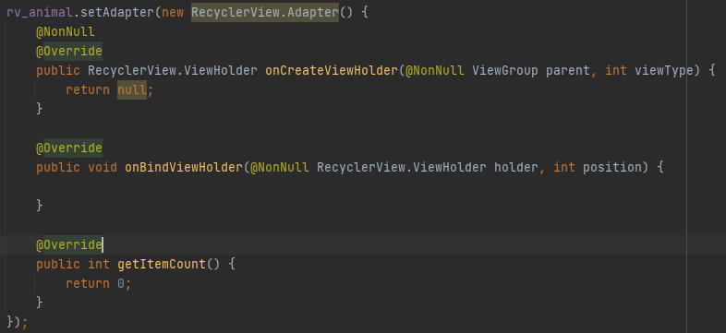

**********************资源值文件建立*******************

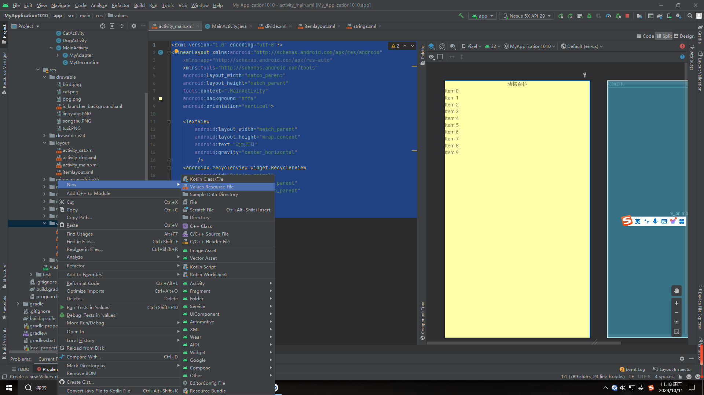
代码实现：
<?xml version="1.0" encoding="utf-8"?>
<resources>
<dimen name="dividerHeight">20dp</dimen>
</resources>

